

DEPLOYMENT DOCUMENT OF OTIS TASK SCHEDULER

February 20, 2019

Mediaagility

|  |  |  |
| --- | --- | --- |
| **#** | **Update/Reviewer** | **Date** |
| 1 | Sonali Nimkarde | Feb 20, 2019 |
| 2 | Prateek Jain | Feb 20, 2019 |

Table of Contents

[**Introduction**](https://docs.google.com/document/d/1zWCIlFrxXlpXgM-5BmPJ8Q3ZPvQVYRaheNRHAQzV3HA/edit?ts=5bdfe61b)[**2**](https://docs.google.com/document/d/1zWCIlFrxXlpXgM-5BmPJ8Q3ZPvQVYRaheNRHAQzV3HA/edit?ts=5bdfe61b)

[**Pre-requisites**](https://docs.google.com/document/d/1zWCIlFrxXlpXgM-5BmPJ8Q3ZPvQVYRaheNRHAQzV3HA/edit?ts=5bdfe61b)[**2**](https://docs.google.com/document/d/1zWCIlFrxXlpXgM-5BmPJ8Q3ZPvQVYRaheNRHAQzV3HA/edit?ts=5bdfe61b)

[**How to start**](https://docs.google.com/document/d/1zWCIlFrxXlpXgM-5BmPJ8Q3ZPvQVYRaheNRHAQzV3HA/edit?ts=5bdfe61b)[**2**](https://docs.google.com/document/d/1zWCIlFrxXlpXgM-5BmPJ8Q3ZPvQVYRaheNRHAQzV3HA/edit?ts=5bdfe61b)

[**Get publish code**](https://docs.google.com/document/d/1zWCIlFrxXlpXgM-5BmPJ8Q3ZPvQVYRaheNRHAQzV3HA/edit?ts=5bdfe61b)[**2**](https://docs.google.com/document/d/1zWCIlFrxXlpXgM-5BmPJ8Q3ZPvQVYRaheNRHAQzV3HA/edit?ts=5bdfe61b)

[**Create folder for publish code**](https://docs.google.com/document/d/1zWCIlFrxXlpXgM-5BmPJ8Q3ZPvQVYRaheNRHAQzV3HA/edit?ts=5bdfe61b)[**3**](https://docs.google.com/document/d/1zWCIlFrxXlpXgM-5BmPJ8Q3ZPvQVYRaheNRHAQzV3HA/edit?ts=5bdfe61b)

[**Schedule the .exefrom HYPERLINK "https://docs.google.com/document/d/1zWCIlFrxXlpXgM-5BmPJ8Q3ZPvQVYRaheNRHAQzV3HA/edit?ts=5bdfe61b" publish code**](https://docs.google.com/document/d/1zWCIlFrxXlpXgM-5BmPJ8Q3ZPvQVYRaheNRHAQzV3HA/edit?ts=5bdfe61b)[**3**](https://docs.google.com/document/d/1zWCIlFrxXlpXgM-5BmPJ8Q3ZPvQVYRaheNRHAQzV3HA/edit?ts=5bdfe61b)

**Introduction**

This code has developed for scheduling the task executions. Windows Task scheduler is used to run the .exe of task execution code at specified time interval. Task Scheduling code is built on .Net 4.5 framework and uses the SQL server 2016 for database related operations.

**Pre-requisites**

1. **Nprinting User with Administrator access is required**

Apply the below listed URL’s on the server to test.

A https://<Nprintingserver>/api/v1/login/ntlm

Sample Result - A

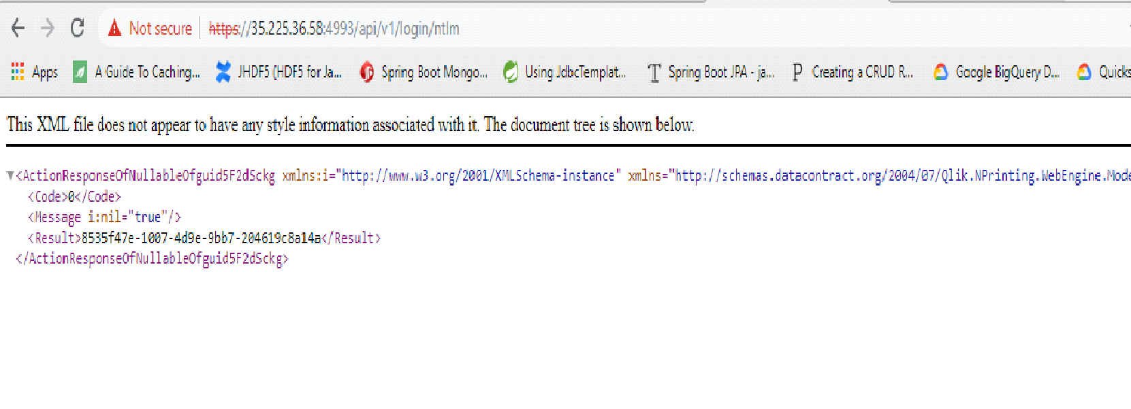

B https://<Nprintingserver>/api/v1/filters/

Sample Result - B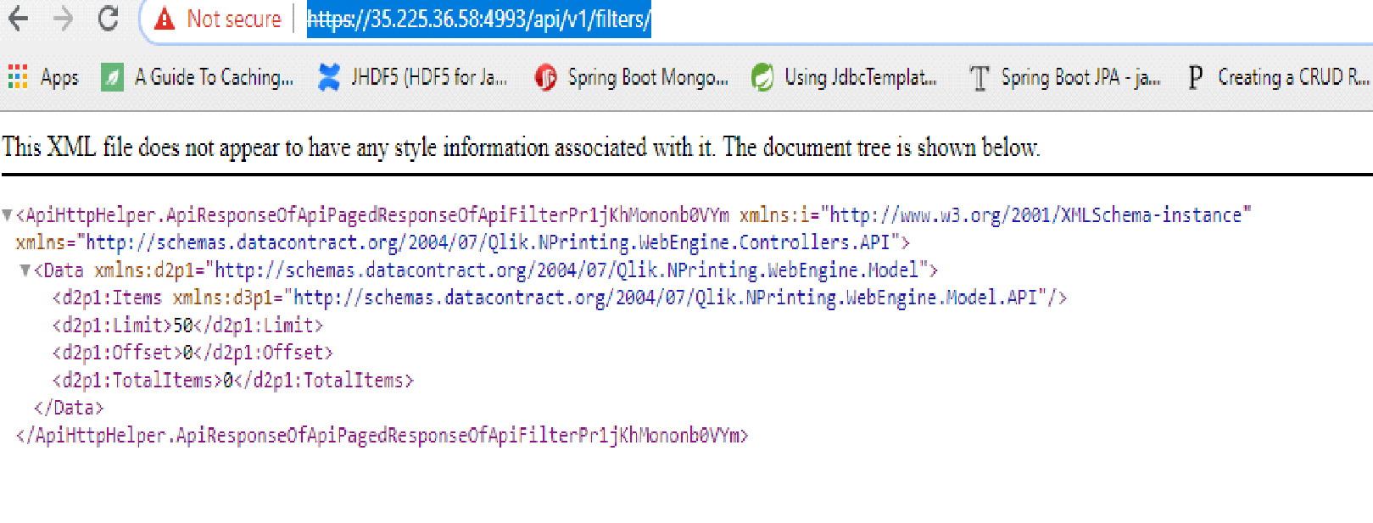

C https://<Nprintingserver>/api/v1/tasks/

Sample Result - C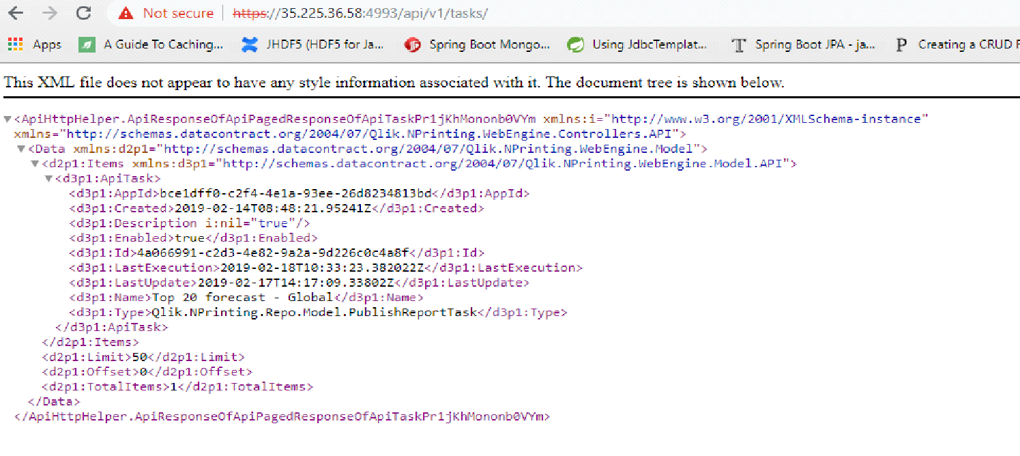

1. **Shared Folders: Create shared folder for Nprinting tasks:**
2. Select the folder which is set as base folder for all the tasks in destination folder.

e.g. C:\NprintingTasks

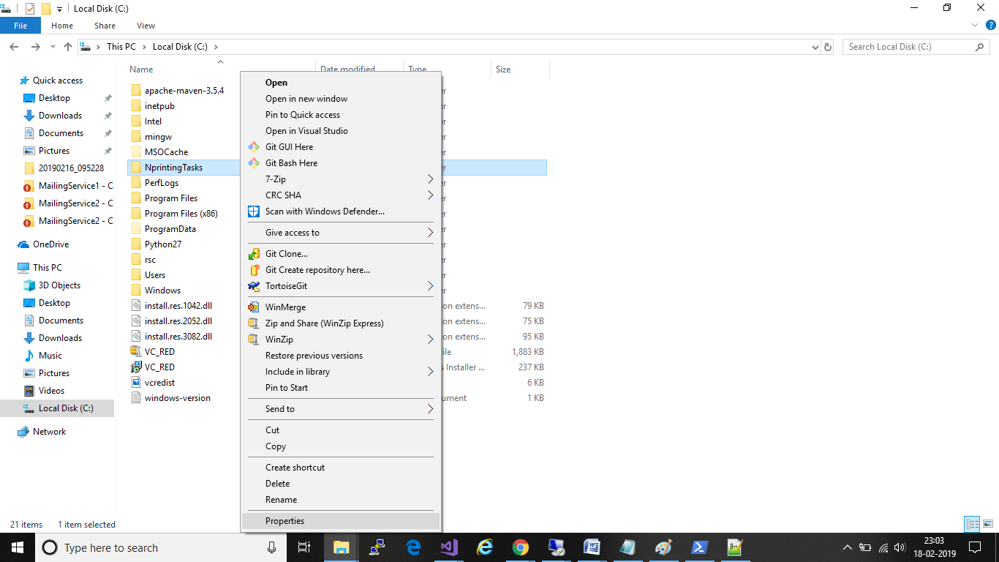

1. Right click on it and select properties

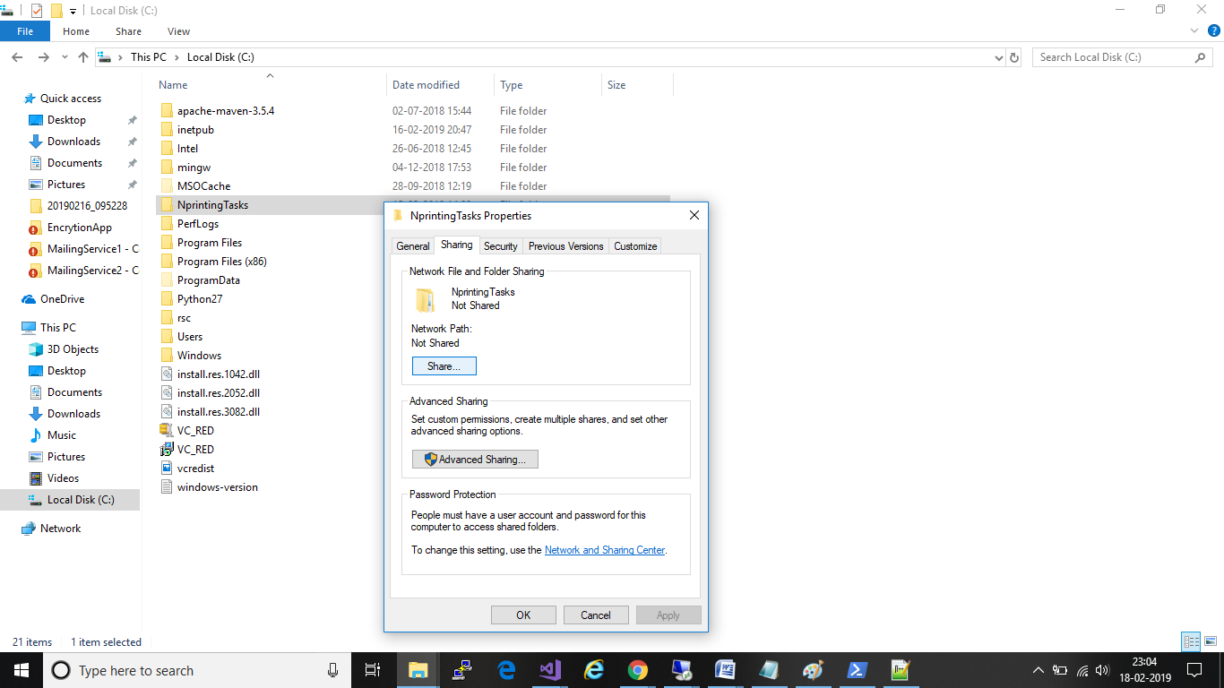

1. Click on Sharing Tab and select share

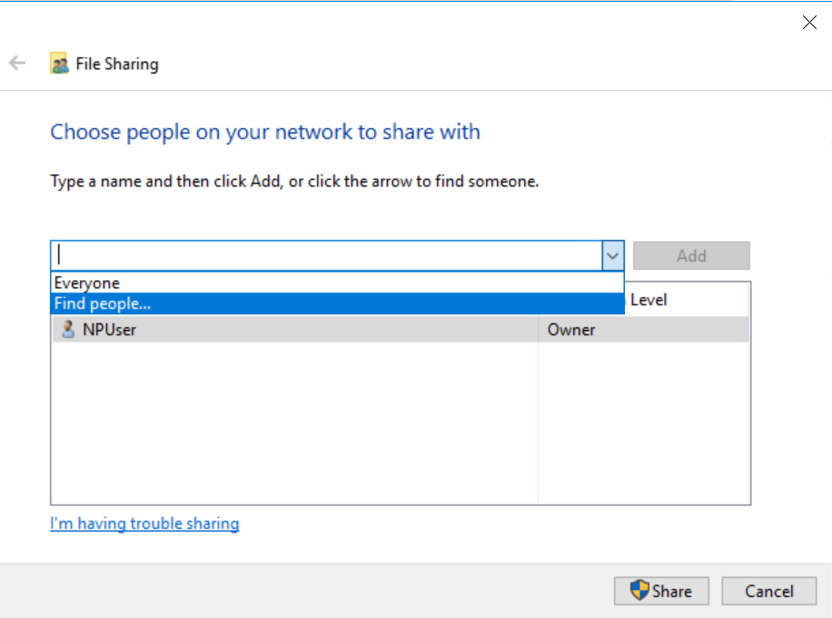

1. Select Find people in dropdown
2. Find people as per below screen shot and click “OK” button.

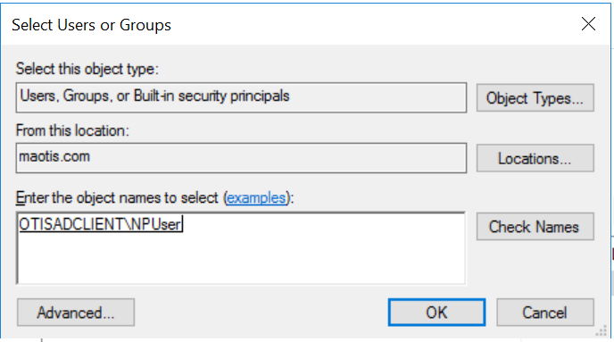

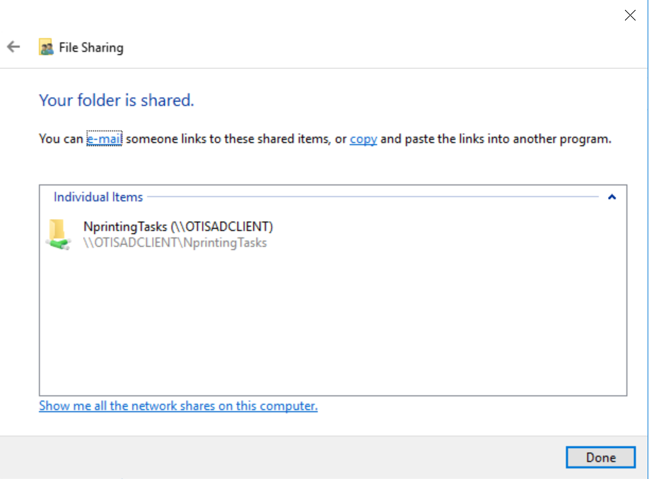

1. We provide the specific control(read, write and full) to the user.
2. Get a message saying folder has been shared.
3. **Folder Destination for nprinting Tasks:**

To Get the reports at defined location need to create correct folder structure at server and follow the same at Nprinting. Here are the steps to do the same

1. Create a Folder with mane as NPrinting Tasks at desired location and Share it with everyone ex: C:\Nprinting Tasks
2. Update the folder path in config file
3. Create a New Folder destination for each task in Nprinting server
4. In Custom Path Update the folder path as provided in config file with task name and Processing folder

ex. C:\Nprinting Tasks\<TaskName as per app database>\Processing

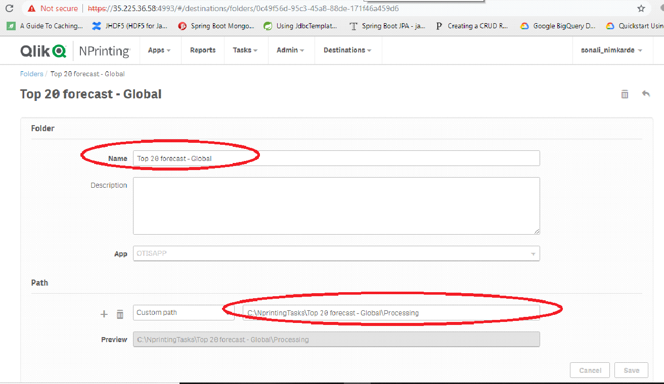

1. Update the tasks to publish at their folder destinations

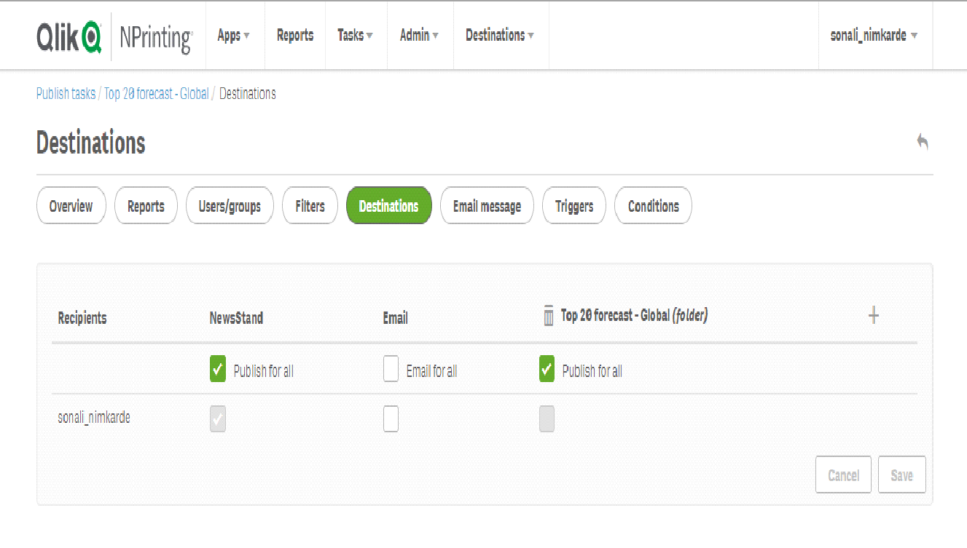

1. **SMTP Mailing server details**

Please follow below steps to verify the mailing server details

1. Open Windows powershell as Administrator

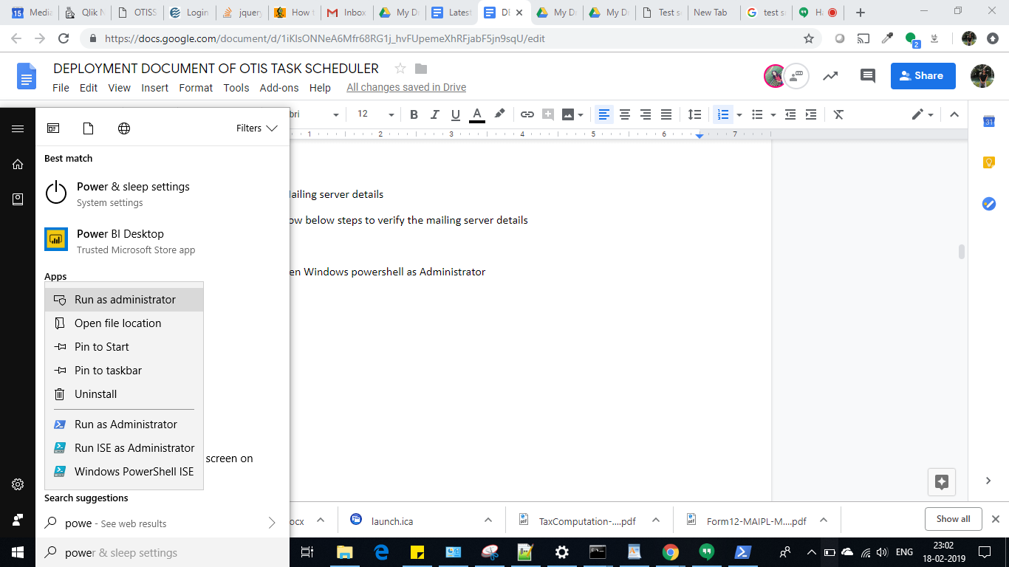

. 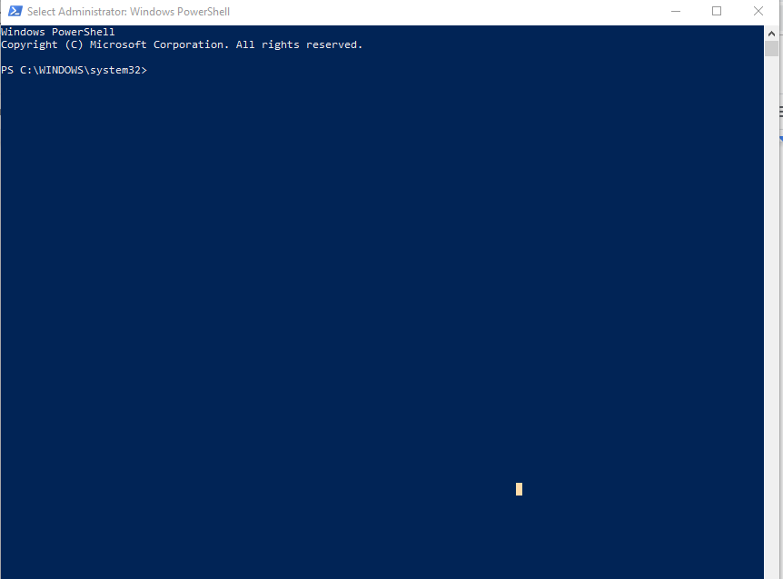

1. Edit below script with SMTP server details and user ID

try{

Send-MailMessage -from <Email_Id> -to <Email_Id> -Subject "Test OK" -Body "Test is OK" -SmtpServer <SMTP Server name> -Credential <Email_Id> -UseSsl -Port 587

}

catch{

Send-MailMessage -from <Email_Id> -to <Email_Id> -Subject "Test OK" -Body "Test is OK" -SmtpServer <SMTP Server name> -Credential <Email_Id> -UseSsl -Port 587

}

1. Past the script at Power shell and press enter
2. Will get a prompt for Password

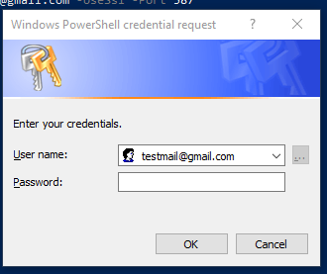

1. Please enter the password and click on ok
2. You will receive the mail to the ID used in From at Powershell

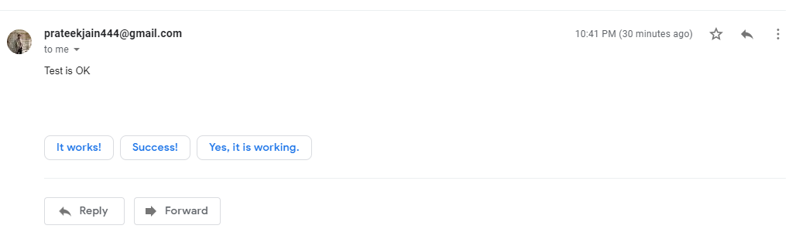

**Application Deployment**

We need to follow the below steps for deploying the Task Scheduler.

* Get the code from Github:
* Get the code from Github.Copy it and paste it on Nprinting Server at desired location.e.g on Disk C create a folder named ‘TaskScheduler’ and paste all the files copied into it.
* Encryt Mailing ServerID, Mailing Server Password, NPrintingUserName and NPrinting Password, DB connection string with the help of ‘EncrytionSecurity.exe’ provided with deployables.

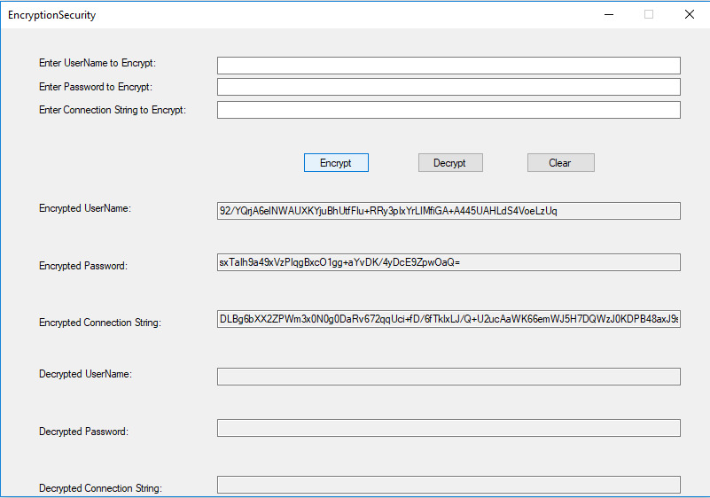

**Config File Changes:**

Select ‘NPrintingScheduler.exe.config” config file and open it Notepad.

Please update the configuration file “NPrintingScheduler.exe.config” as per below.

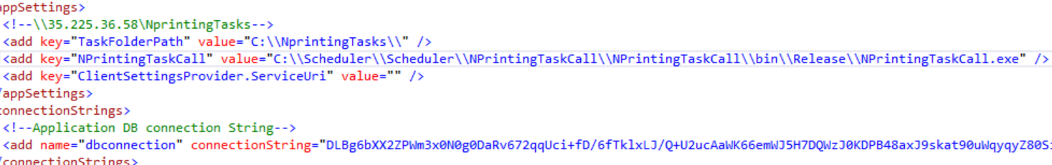

* Set the folder path of the report, where we will receive the Nprinting report after task execution.
* Set the another exe path.
* Add the encrypted database connection string or the application.

Select ‘NPrintingTaskCall.exe.config” config file and open it Notepad.

Please update the configuration file “NPrintingTaskCall.exe.config” as per below.

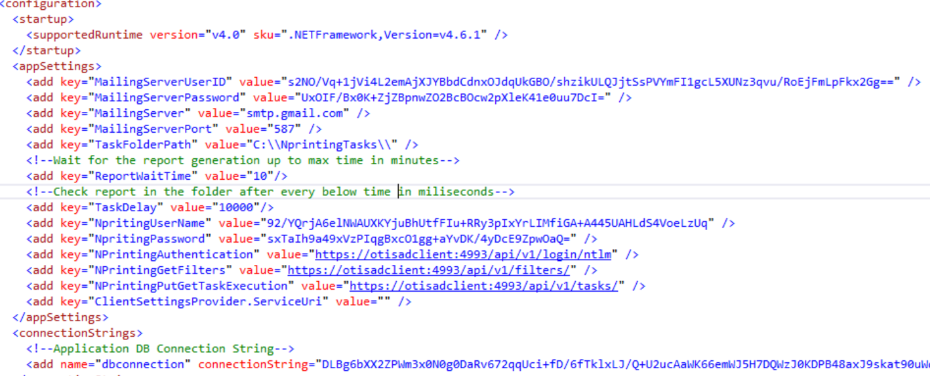

* Add the encrypted mail server user name and password.
* Add encrypted Nprinting user name and password.
* Add the encrypted database connection string or the application.

**Steps for scheduling a task:**

* Right click on task scheduler and select create task option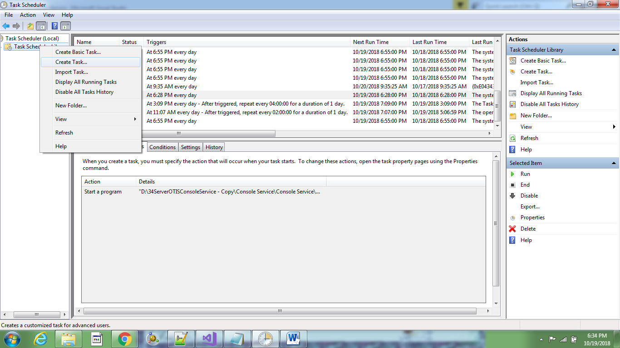
* Give appropriate name to the task. e.g. MailScheduler.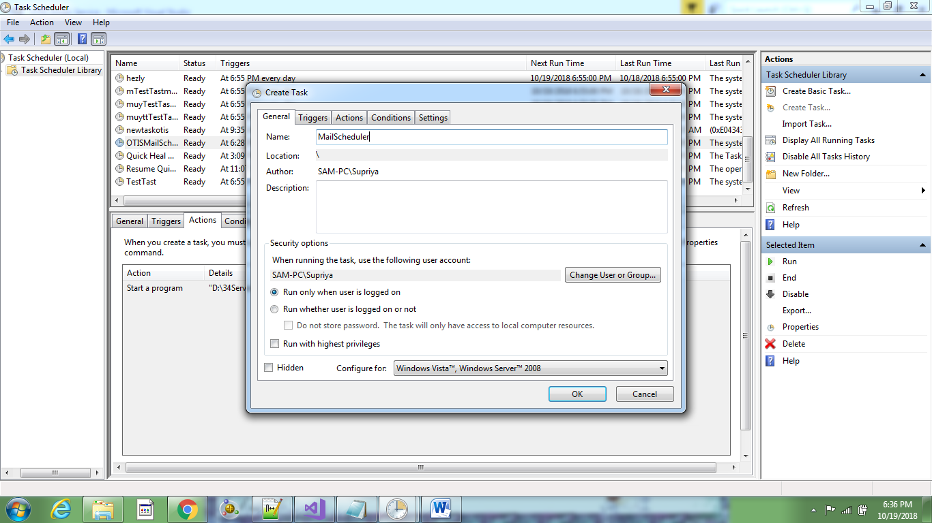
* Click on Triggers and select set new trigger. Do the settings as shown in the below figure. 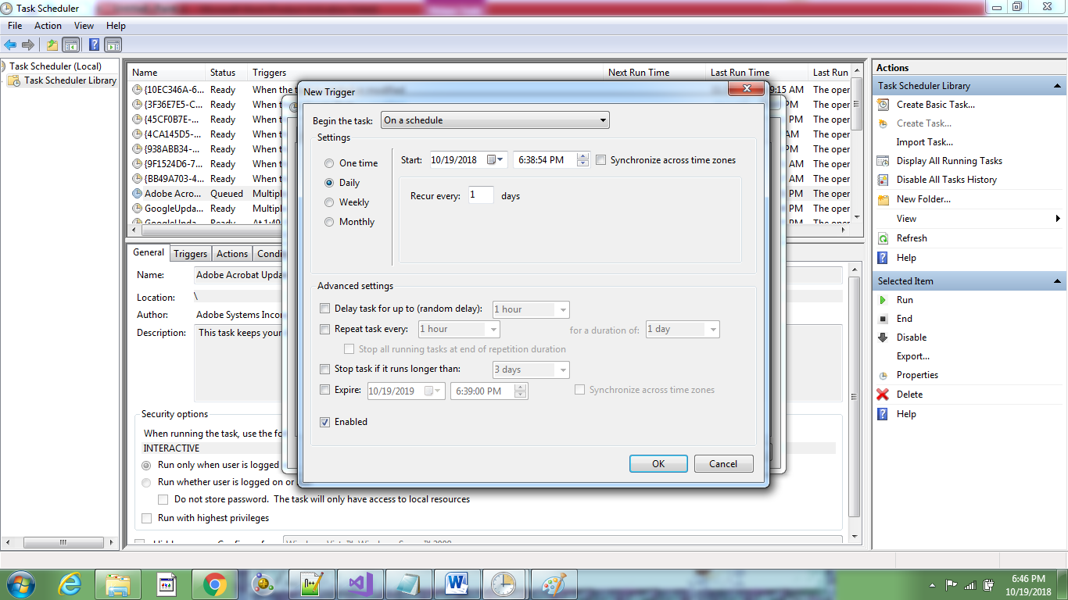
* Click on Action and add a new one.

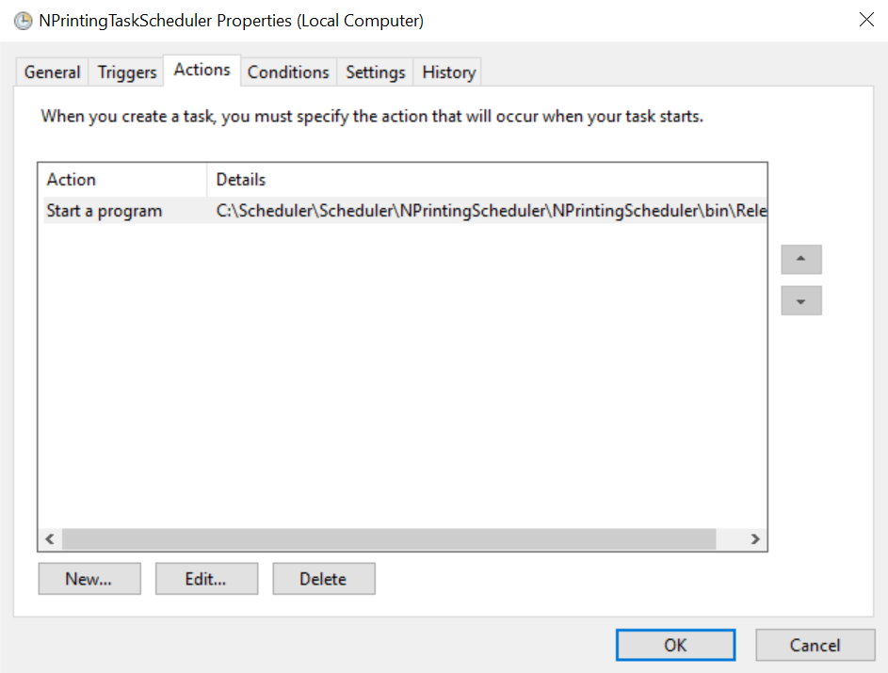

* Browse the application NPrintingScheduler.exe file which was copied from github and pasted in ‘TaskScheduler’ folder.

